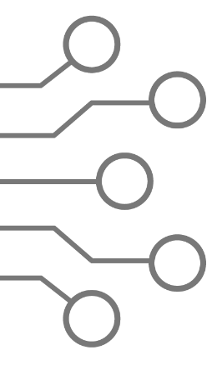

**North South University**

Department of Electrical & Computer Engineering

**EEE 111 / ETE 111 – Lab**

Electronics - 1

Faculty **:** Dr. Riasat Khan

Lab Instructor **:** Mehrab Hossain Likhon

**Lab Report**

Experiment No **:** 08

Experiment Name **:** Study of Switching Characteristics

Date of Performance **:** 28-11-2021

Date of Submission **:** 07-12-2021

Section**:** 01 Group No**: 01**

Group Member Info and Remarks**:**

|  |  |  |  |
| --- | --- | --- | --- |
| *Name* | *ID* | *Writer* | *Remarks* |
| 1. Md . Khalilur Rahman | 1811835042 | □ |  |
| 1. Md. Raqibur Rahman Roni | 1812935642 | □ |
| 1. Abdur Rahman Fahad | 1912024642 | □ |
| 1. Md. Saeem Hossain Shanto | 1912218642 | **✓** |

**Experiment Name:** Study of Switching Characteristics

**Abstract:** We studied switching characteristics of MOSFET circuit and how changes in gate terminal can change the output voltage of the MOSFET.

**Theory:**

The MOSFET (Metal Oxide Semiconductor Field Effect Transistor) transistor is a semiconductor device that is widely used for switching purposes and for the amplification of electronic signals in electronic devices. A MOSFET is either a core or integrated circuit where it is designed and fabricated in a single chip because the device is available in very small sizes. The introduction of the MOSFET device has brought a change in the domain of switching in electronics.

A MOSFET is a four-terminal device having source(S), gate (G), drain (D) and body (B) terminals. In general, The body of the MOSFET is in connection with the source terminal thus forming a three-terminal device such as a field-effect transistor. MOSFET is generally considered as a transistor and employed in both the analog and digital circuits. A MOSFET is a four-terminal device having source(S), gate (G), drain (D) and body (B) terminals. In general, The body of the MOSFET is in connection with the source terminal thus forming a three-terminal device such as a field-effect transistor. MOSFET is generally considered as a transistor and employed in both the analog and digital circuits.

* A MOSFET can function in two ways-

1. Depletion Mode
2. Enhancement Mode

**Depletion Mode:**

When there is no voltage across the gate terminal, the channel shows its maximum conductance. Whereas when the voltage across the gate terminal is either positive or negative, then the channel conductivity decreases.

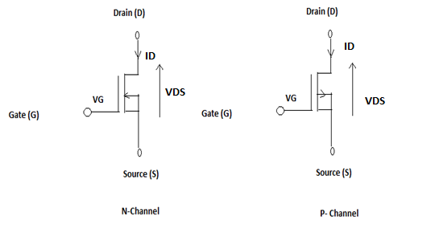

**Enhancement Mode:**

When there is no voltage across the gate terminal, then the device does not conduct. When there is the maximum voltage across the gate terminal, then the device shows enhanced conductivity.

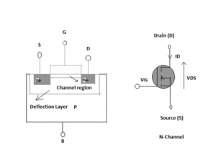

A common application of MOSFETs is switches in analog and digital circuits. Switches in analog circuits can be used for example in data acquisition systems, where they serve as analog multiplexors, which allow the selection of one of several data inputs.

**MOSFET Regions of Operation**

To the most general scenario, the operation of this device happens mainly in three regions and those are as follows:

* **Cut-off Region** – It is the region where the device will be in the OFF condition and there zero amount of current flow through it. Here, the device functions as a basic switch and is so employed as when they are necessary to operate as electrical switches.
* **Saturation Region** – In this region, the devices will have their drain to source current value as constant without considering the enhancement in the voltage across the drain to source. This happens only once when the voltage across the drain to source terminal increases more than the pinch-off voltage value. In this scenario, the device functions as a closed switch where a saturated level of current across the drain to source terminals flows. Due to this, the saturation region is selected when the devices are supposed to perform switching.
* **Ohmic Region** – It is the region where the current across the drain to source terminal enhances with the increment in the voltage across the drain to source path. When the MOSFET devices function in this linear region, they perform amplifier functionality.

**Ideal Switch Characteristics:**

When a MOSFET is supposed to function as an ideal switch, it should hold the below properties and those are**-**

1. In the ON condition, there has to be the current limitation that it carries
2. In the OFF condition, blocking voltage levels should not hold any kind of limitations
3. When the device functions in ON state, the voltage drop value should be null
4. The resistance in OFF state should be infinite
5. There should be no restrictions on the speed of operation

**Practical Switch Characteristics**

As the world is not just stuck to ideal applications, the functioning of MOSFET is even applicable for practical purposes. In the practical scenario, the device should hold the below properties

1. In the ON condition, the power managing abilities should be limited which means that the flow of conduction current has to be restricted.
2. In the OFF state, blocking voltage levels should not be limited
3. Turning ON and OFF for finite times restricts the limiting speed of the device and even limits the functional frequency
4. In the ON condition of the MOSFET device, there will be minimal resistance values where this results in the voltage drop in forwarding bias. Also, there exists finite OFF state resistance that delivers reverse leakage current

**N-channel Enhancement-type MOSFET:**

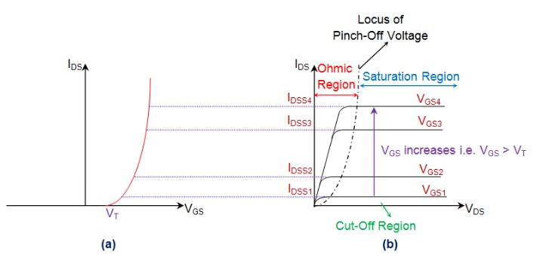

The following figure, shows the transfer characteristics (drain-to-source current IDS versus gate-to-source voltage VGS) of n-channel Enhancement-type MOSFETs. From this, it is evident that the current through the device will be zero until the VGS exceeds the value of threshold voltage VT.

This is because under this state, the device will be void of channel which will be connecting the drain and the source terminals.

Under this condition, even an increase in VDS will result in no current flow as indicated by the corresponding output characteristics (IDS versus VDS) shown by Figure. As a result, this state represents nothing but the cut-off region of MOSFET’s operation.

Next, once VGS crosses VT, the current through the device increases with an increase in IDS initially (Ohmic region) and then saturates to a value as determined by the VGS (saturation region of operation) i.e. as VGS increases, even the saturation current flowing through the device also increases.

This is evident by the figure where IDSS2 is greater than IDSS1 as VGS2 > VGS1, IDSS3 is greater than IDSS2 as VGS3 > VGS2, so on and so forth. Further, the figure also shows the locus of pinch-off voltage (black discontinuous curve), from which VP is seen to increase with an increase in VGS.

**P-channel Enhancement-type MOSFET:**

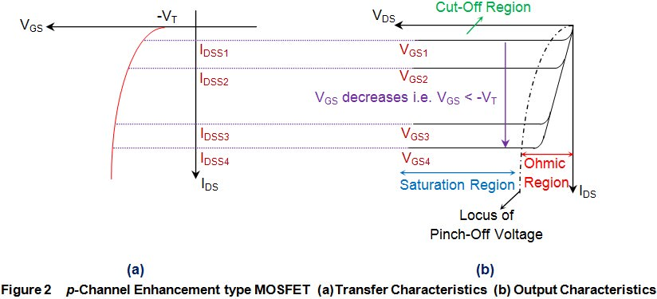

The figure shows the transfer characteristics of p-type enhancement MOSFETs from which it is evident that IDS remains zero (cut-off state) until VGS becomes equal to -VT.

This is because, only then the channel will be formed to connect the drain terminal of the device with its source terminal. After this, the IDS is seen to increase in reverse direction (meaning an increase in ISD, signifying an increase in the device current which will flow from source to drain) with the decrease in the value of VDS.

This means that the device is functioning in its ohmic region wherein the current through the device increases with an increase in the applied voltage (which will be VSD).

However, as VDS becomes equal to –VP, the device enters into saturation during which a saturated amount of current (IDSS) flows through the device, as decided by the value of VGS.

Further it is to be noted that the value of saturation current flowing through the device is seen to increase as the VGS becomes more and more negative i.e. saturation current for VGS3 is greater than that for VGS2 and that in the case of VGS4 is much greater than both of them as VGS3 is more negative than VGS2 while VGS4 is much more negative when compared to either of them .

In addition, from the locus of the pinch-off voltage it is also clear that as VGS becomes more and more negative, even the negativity of VP also increases.

**N-channel Depletion-type MOSFET:**

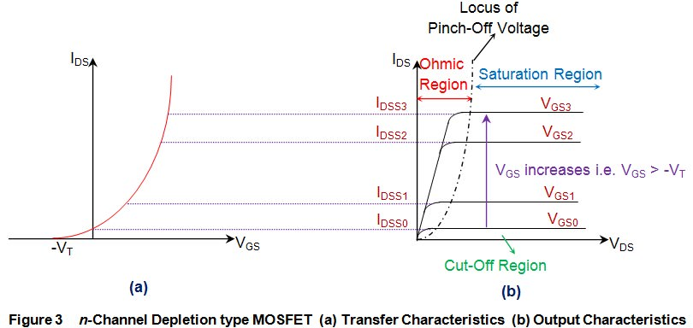The transfer characteristics of n-channel depletion MOSFET shown by the figure indicate that the device has a current flowing through it even when VGS is 0V. This indicates that these devices conduct even when the gate terminal is left unbiased, which is further emphasized by the VGS0 curve of the figure.

Under this condition, the current through the MOSFET is seen to increase with an increase in the value of VDS (Ohmic region) until VDS becomes equal to pinch-off voltage VP. After this, IDS will get saturated to a particular level IDSS (saturation region of operation) which increases with an increase in VGS i.e. IDSS3 > IDSS2 > IDSS1, as VGS3 > VGS2 > VGS1. Further, the locus of the pinch-off voltage also shows that VP increases with an increase in VGS.

However, it is to be noted that, if one needs to operate these devices in cut-off state, then it is required to make VGS negative and once it becomes equal to −VT, the conduction through the device stops (IDS=0) as it gets deprived of its n-type channel.

**P-channel Depletion-type MOSFET:**

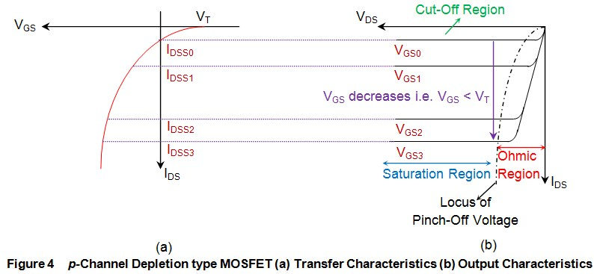

The transfer characteristics of p-channel depletion mode MOSFETs show that these devices will be normally ON, and thus conduct even in the absence of VGS. This is because they are characterized by the presence of a channel in their default state due to which they have non-zero 0 IDS for VGS = 0V, as indicated by the VGS0 curve of the figure.

Although the value of such a current increases with an increase in VDS initially (ohmic region of operation), it is seen to saturate once the VDS exceeds VP (saturation region of operation). The value of this saturation current is determined by the VGS, and is seen to increase in negative direction as VGS becomes more and more negative.

For example, the saturation current for VGS3 is greater than that for VGS2 which is however greater when compared to that for VGS1. This is because VGS2 is more negative when compared to VGS, and VGS3 is much more negative when compared to either of them. Next, one can also note from the locus of pinch-off point that even VP starts to become more and more negative as the negativity associated with the VGS increases.

Lastly, it is evident from the figure, that in order to switch these devices OFF, one needs to increase VGS such that it becomes equal to or greater than that of the threshold voltage VT. This is because, when done so, these devices will be deprived of their p-type channel, which further drives the MOSFETs into their cut-off region of operation.

**Some Important Applications of MOSFET:**

1. MOSFET is used for (mostly)switching and amplifying electronics signals in the electronic devices.
2. It is used as an inverter.
3. It can be used in digital circuit.
4. MOSFET can be used as a high frequency amplifier.
5. It can be used as a passive element. Example -resistor, capacitor and inductor.
6. It can be used in brushless DC motor drive.
7. It can be used in electronic DC relay.
8. It is used in switch mode power supply (SMPS).

**Equipment List:**

|  |  |  |
| --- | --- | --- |
| Equipment Name | Value | Quantity |
| 1. MOSFET | IRF540CF | 1 piece each |
| 1. Resistor | 100K(ohm) | 1 piece each |
| 1. POT |  | 1 unit |
| 1. Trainer Board |  | 1 unit |
| 1. DC Power Supply |  | 2 unit |
| 1. Digital Multimeter |  | 1 unit |
| 1. Chords and Wires |  | As required |

**Circuit Diagram:**

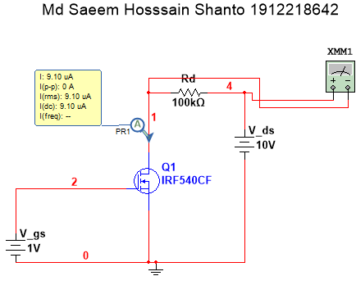

*Figure 1: MOSFET Switching Circuit with V_ds = 10V*

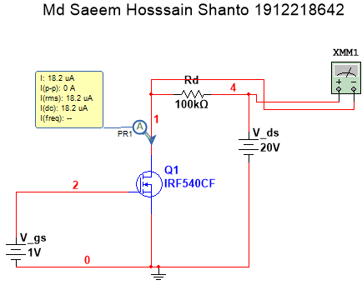

*Figure 2: MOSFET Switching Circuit with V_ds = 20V*

**Data and Results:**

* **Table 1 for VDD = 10V:**

|  |  |  |
| --- | --- | --- |
| VDD = 10 V |  |  |
| VGS (V) | ID (µA) | VL(v) |
| 0 | 9.10 | 0.91 |
| 0.5 | 9.10 | 0.91 |
| 1 | 9.10 | 0.91 |
| 1.5 | 9.10 | 0.91 |
| 2 | 9.10 | 0.91 |
| 2.5 | 9.10 | 0.91 |
| 3 | 9.10 | 0.91 |
| 3.5 | 9.10 | 0.91 |
| 4 | 9.10 | 0.91 |
| 4.5 | 9.10 | 0.91 |
| 5 | 100 | 10 |
| 5.5 | 100 | 10 |
| 6 | 100 | 10 |
| 6.5 | 100 | 10 |
| 7 | 100 | 10 |
| 7.5 | 100 | 10 |
| 8 | 100 | 10 |

When VDD = 10V, the threshold gate voltage is at VGS = 5V where the value of ID changes from a constant of 9.10 µA to 100µA

* **Table 2 for VDD = 20V:**

|  |  |  |
| --- | --- | --- |
| VDD = 20 V |  |  |
| VGS (V) | ID (µA) | VL(v) |
| 0 | 18.2 | 1.82 |
| 0.5 | 18.2 | 1.82 |
| 1 | 18.2 | 1.82 |
| 1.5 | 18.2 | 1.82 |
| 2 | 18.2 | 1.82 |
| 2.5 | 18.2 | 1.82 |
| 3 | 18.2 | 1.82 |
| 3.5 | 18.2 | 1.82 |
| 4 | 18.2 | 1.82 |
| 4.5 | 18.2 | 1.82 |
| 5 | 200 | 20 |
| 5.5 | 200 | 20 |
| 6 | 200 | 20 |
| 6.5 | 200 | 20 |
| 7 | 200 | 20 |
| 7.5 | 200 | 20 |
| 8 | 200 | 20 |

When VDD = 20V, the threshold gate voltage is at VGS = 5V where the value of ID changes from a constant of 18.20 µA to 200µA

**Result Analysis:**

In table-1 for VDD = 10V, we see that when the input gate voltage is less then 5V, the output load voltage is less than 1 volt (0.9V) and load current is ID = 9.1 (µA) which is kind of off stage. But when the input gate voltage becomes 5V or more then 5V the output load voltage becomes 10volt, load current becomes 100 µA and it is kind of ON stage.

In table-2 we see that when the input gate voltage is less then 5V, the output load voltage is less than 2V and load current is 18.2 µA which is so little amount. But when the input gate voltage becomes 5V or more than that the output load voltage becomes 20V and load current becomes 200 µA.

So, we can see the MOSFET IRF540CF switches on at input gate voltage 5V and 5V is the threshold gate voltage of MOSFET IRF540CF.

**Conclusion:**

As we see MOSFET needs a threshold gate input voltage to switch it on, it is suitable to use as switch circuits. MOSFET IRF540CF only switches on when input gate voltage is equal to or more than 5volt, otherwise it switches off the circuit. Therefore, it’s input threshold gate voltage should be 5volt.

**References:**

1. <https://www.electrical4u.com/mosfet-characteristics/>
2. https://www.polytechnichub.com/application-mosfet-metal-oxide-semiconductor-fet